Multi Camera mount (3 cameras 1 Clamp)

Back Side camera bracket
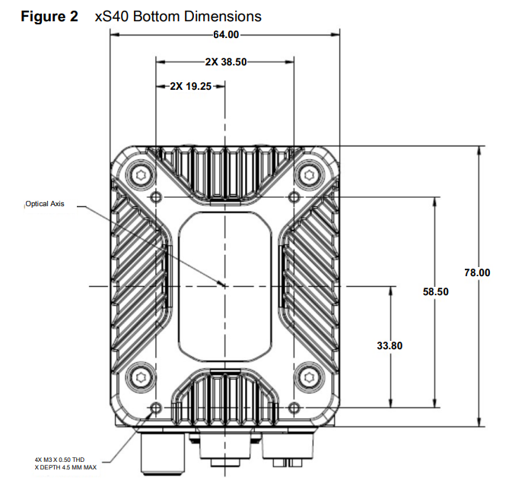

Mounting screws
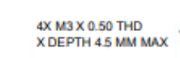
I set the base thickness to 5 mm, but I hide the screw head under the surface so I can use M3 x 6 mm. The anchor thickness is now 1.8 mm
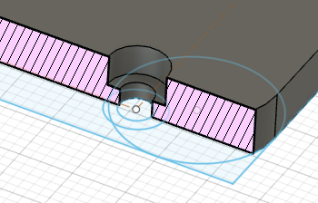

Multi Camera mount 4.0 (3 cameras 1 Clamp)
TBD

Multi Camera mount 3.0 (3 cameras 1 Clamp)
Improvements:
- Rounded mounting plates improvements (8 mm radius instead of 10)
- Quick disconnect fastner / screw that can be operated without tools
- Embossed screws head for the camera plate.

Mounting Screw

Screw Head
Head Size: 12 mm diameter
Head Height: 7 mm to maximize the usability with bare hands
The arrow is oriented as the locking pin
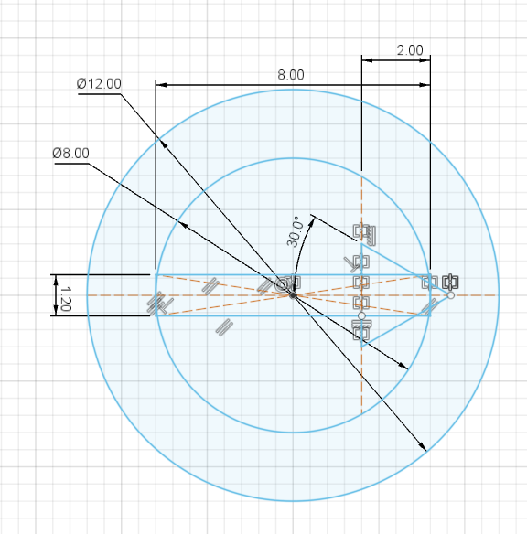 | 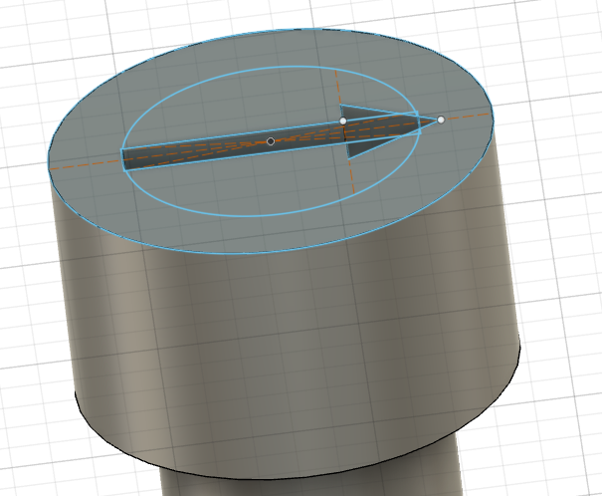

Screw barrel
8 mm diameter
21 mm high

Screw locking pin
The end of the screw is used to lock the screw in place
It is just 2 mm bigger than the barrel
The arrow is aligned to the one on the screw head.
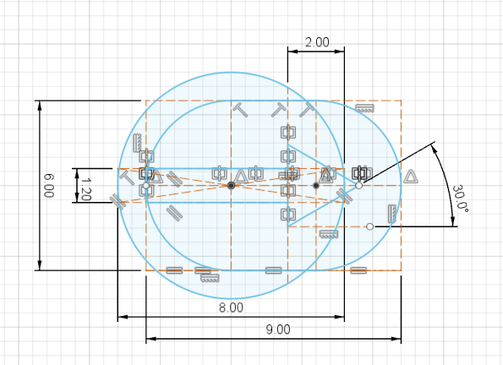 | 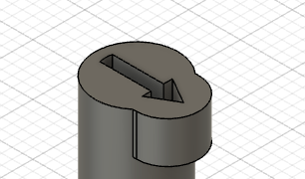

Screw final view
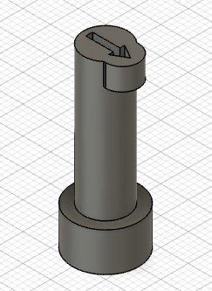 | 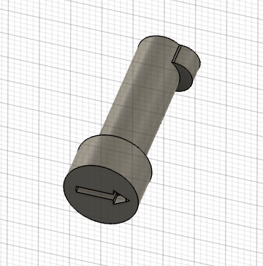

Camera Plate
The camera plate now includes a slot for the screw
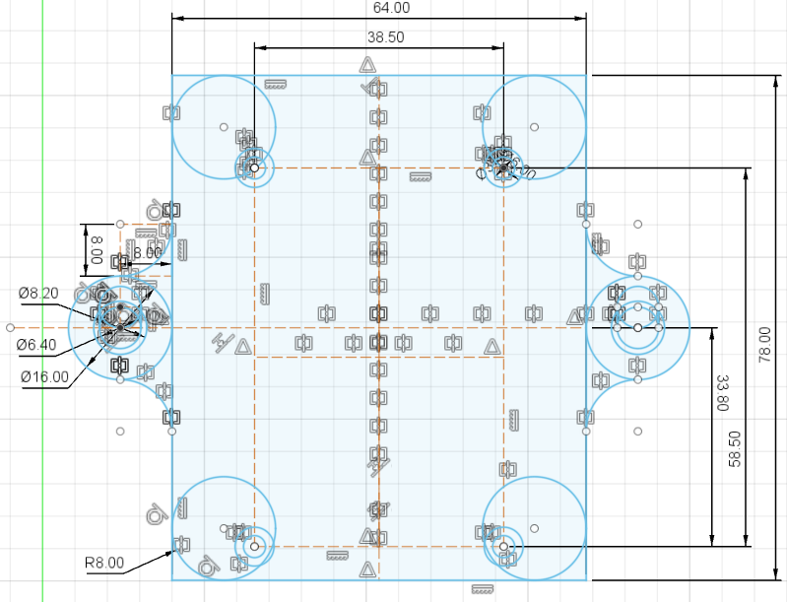
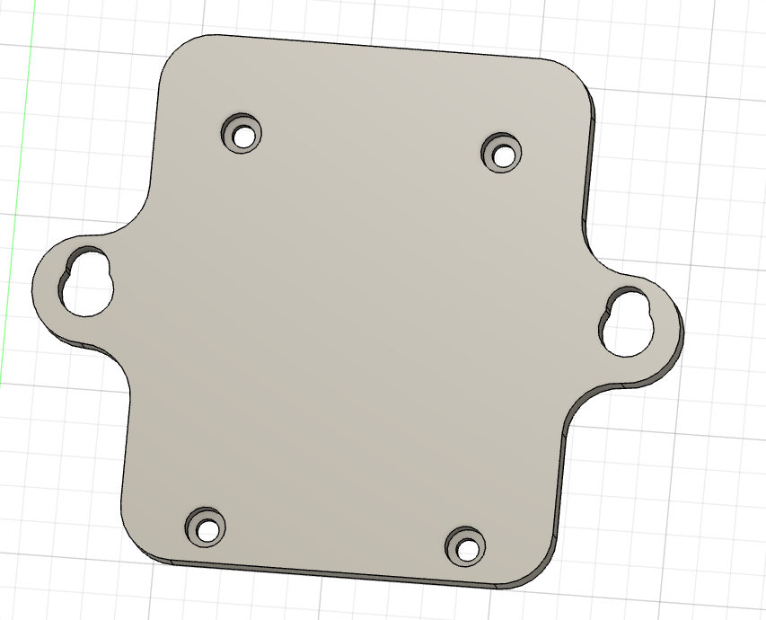

Support Beam
The beam now has a top and bottom since in one side we need the receptacle for the screw pin.
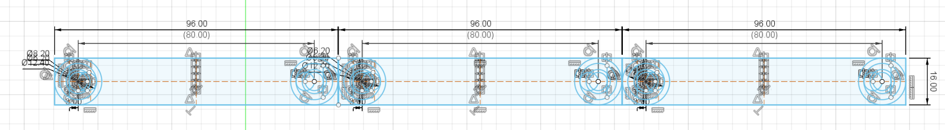
The receptacle is formed by an 8.20 mm and one 6.20 mm circle. A stop line in the back is used to limit the rotation to +/- 90°. Left and right receptacles are symmetric.
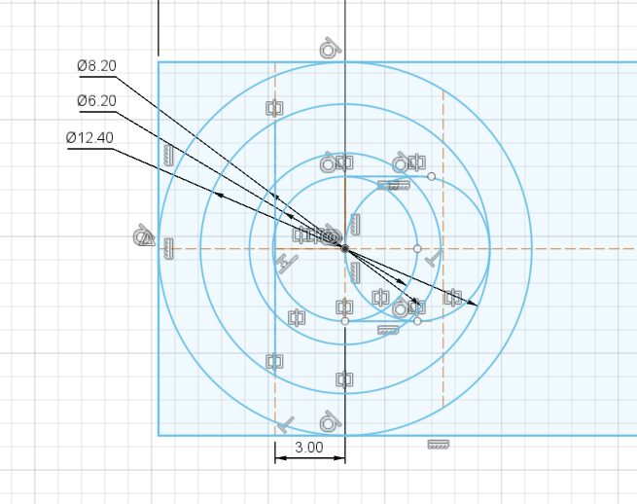
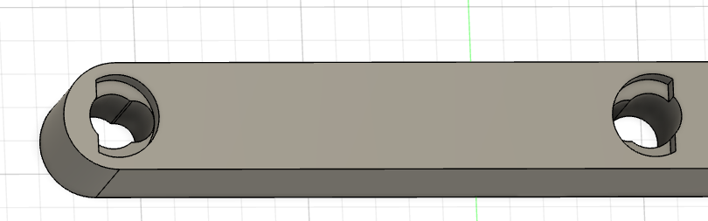

Printing Layout
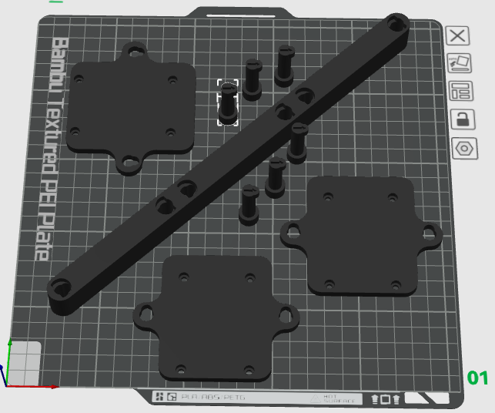

Final Result 3.0
This is the resulting kit
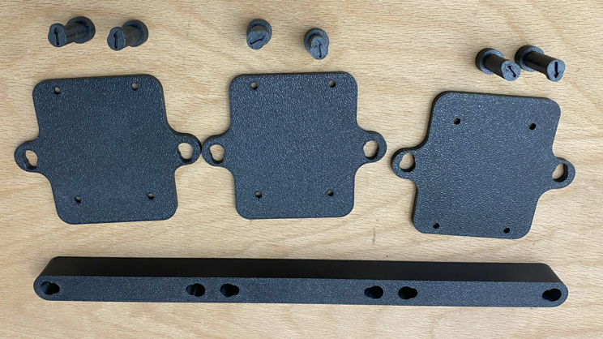
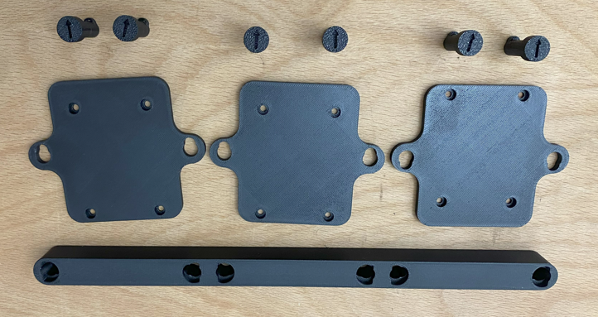

Camera mounting plate and its screws
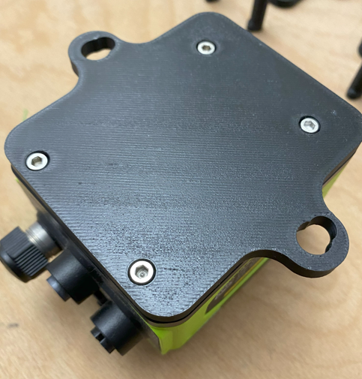
Now the rounded corners are perfect!

Possible improvements
- Add a text message to the camera screw side, since it is not simple to understand the screws has a hiding hole so the head is not emerging from the camera plate back, like a countersunk screw.
- Add 0.5 mm to the screw and mount it using a O-Ring. This should ensure a better fixing against vibrations.
8 x 1.5 O-Ring should be perfect
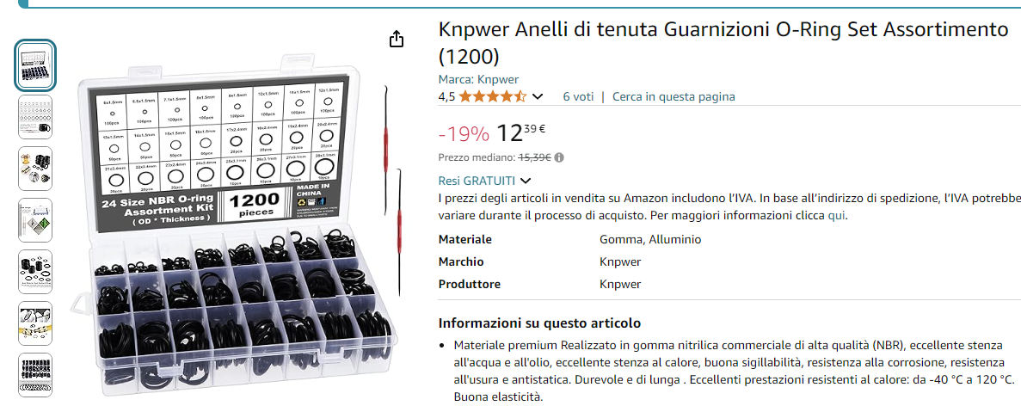

Multi Camera mount 2.0 (3 cameras 1 Clamp)
Improvements:
- Better alignment of the beam and the mounting plate
- Rounded mounting plates (10 mm radius)

Camera Plate
I add 4 R10 circles to round the plate and make it smooth
Changed the side mounting holes with a 16 mm rounded flange to better adapt to the beam
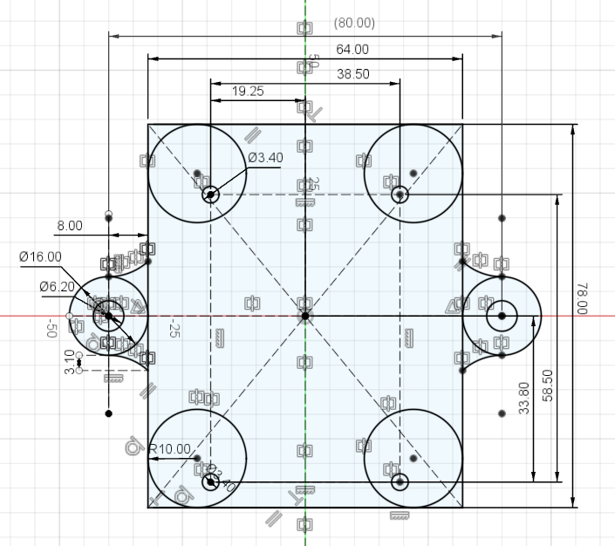

Support Beam
Total length: 288,40 mm
Camera distance: 96,20 mm
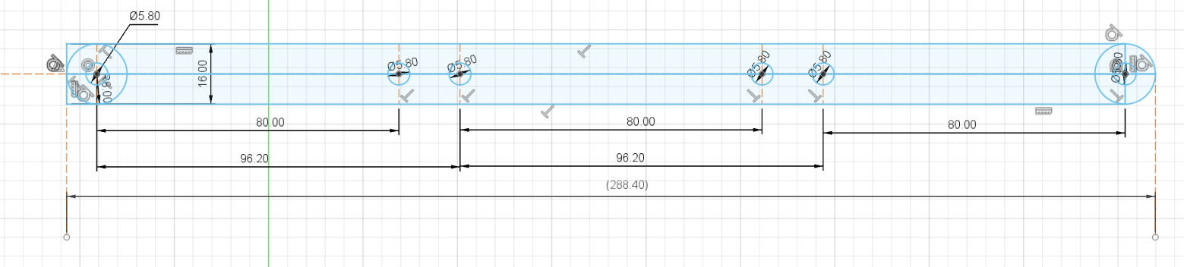

Printing layout

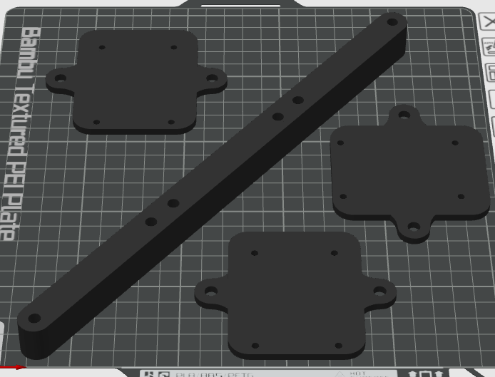

Final result 2.0
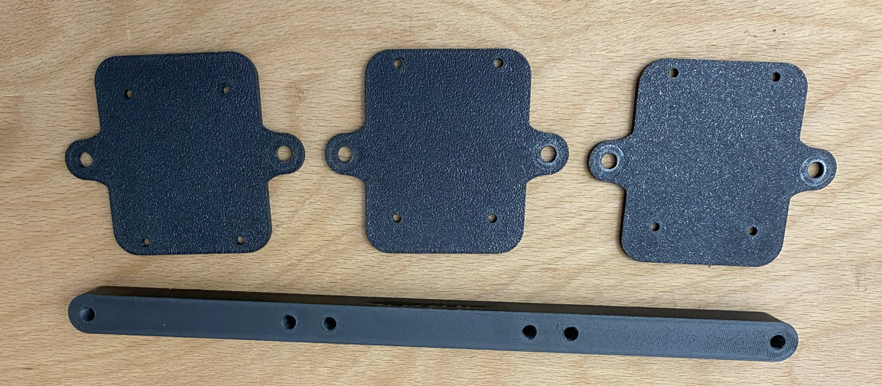
Camera plate mounted to the camera
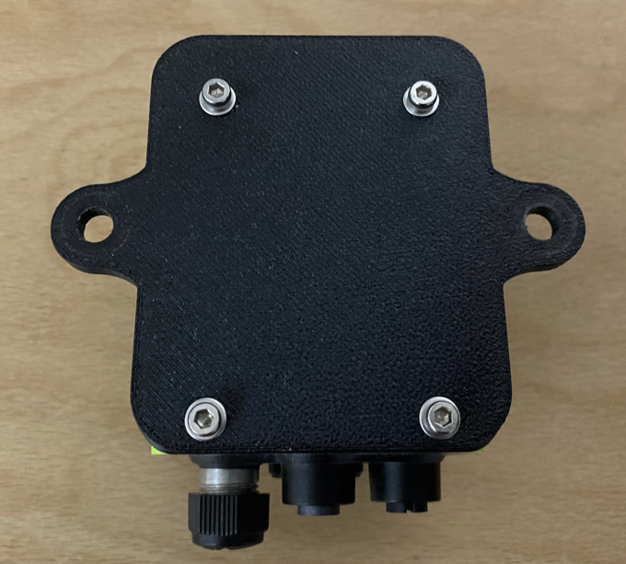
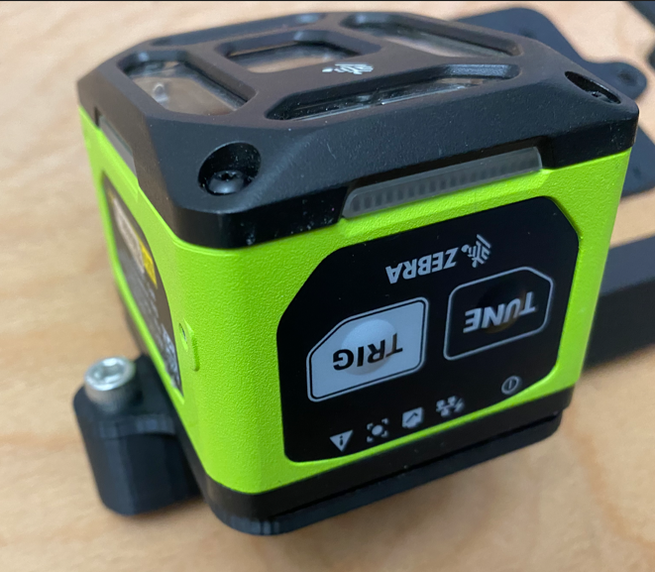 | 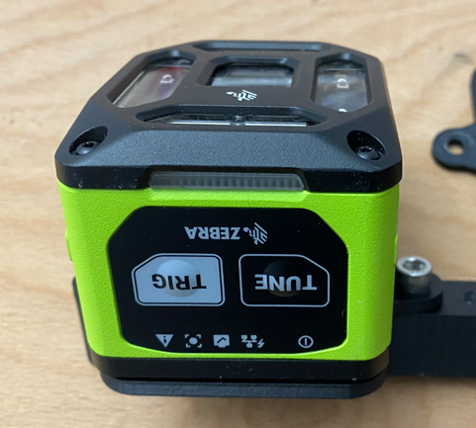

Possible improvements
The rounding diameter is not ok, better try with a lower radius (current radius is 10 mm)
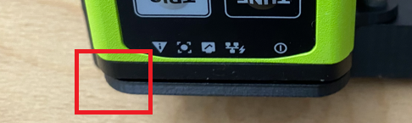

Multi Camera mount 1.0 (3 cameras 1 Clamp)

Support Beam
2 x 6 mm screws for each camera → 6 Screws
2 x 6mm washers for each camera → 6 Washers
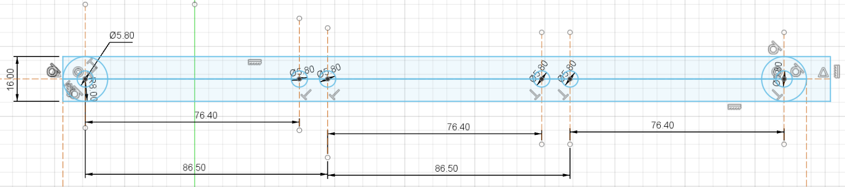

Camera Plate
Thickness: 4 mm
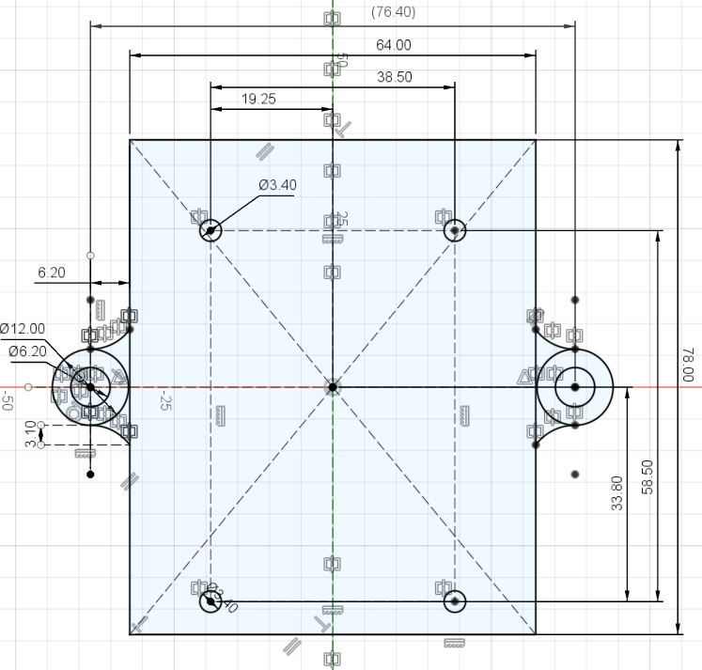

Top view

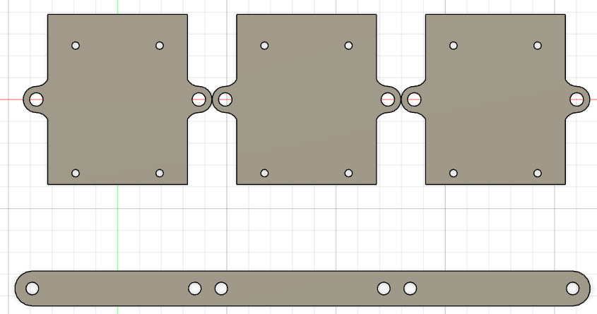

Final result 1.0
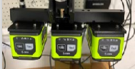 | 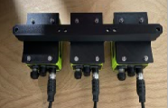 | 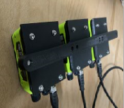

Possible improvements

Camera mount
Since the camera is rounded, so should be the camera mount. Having it squared makes it ugly
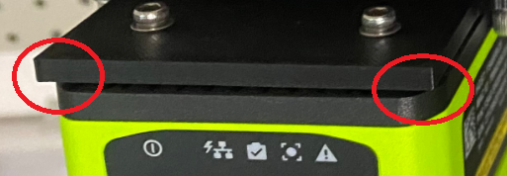

Beam and camera mount joint
The beam is 16 mm wide, the mounting fixture is 12 mm wide, hence this give an impression of mismatching
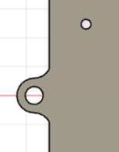 | 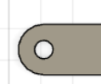 | 

